**Immerse yourself in a 10 day journey of self discovery and care in India**

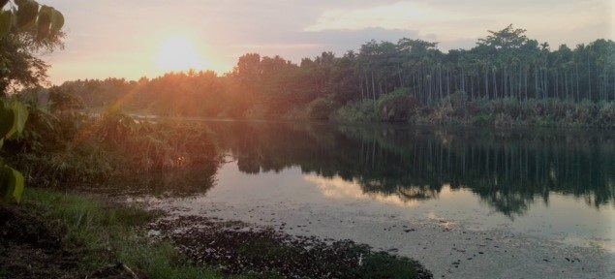

**Hosted by Tracey Burrows & Reem Al Mealla**

**Dates: 7 – 16 August 2017**

**Location: Kerala, South India**

Are you ready to immerse yourself in the simplicity of an authentic Yogic lifestyle? This is a unique opportunity to expand your knowledge of traditional Sivananda Yoga in India, through the expert knowledge and guidance of genuine Indian Yoga masters.

This 10 day retreat follows a spiritual Ashram style programme and is suitable for practitioners of all levels. You'll be immersed in the breathtaking natural surroundings of Moozhikulam sala eco village which looks over the life giving waters of the Chalakkudy River in Cochin.

The course is designed for health conscious people with an open mind and an easy-going attitude. This is a great opportunity to either re-connect with Bhoomaji and Swamiji Yogesh or to make new connections with them.

**Meet Your Esteemed Teachers**

**Bhooma Chaitanya (known as Bhoomaji)**

**School Director, Main Teacher & Yoga Alliance E-RYT – 500**

Bhoomaji started practicing yoga in 1988. He has 18 years experience of teaching yoga. Born and educated in Kerala (South India), Bhoomaji entered into the monastic life of renunciation & spirituality at the age of 18. After seven years studying the Sanskrit language and scriptures in Sivagiri Math in Varkala, he moved on to Sivananda Ashram in Neyyar Dam, Kerala - for the intense practice of yoga sadhana (pranayama practice). From the Sivananda Tradition, Bhoomaji completed the Yoga Teachers Training Course and Advanced Teachers Training Course (ATTC) in 1996 and has also completed three Sadhana Intensive courses since then.  After completing the ATTC, Bhoomaji lived in a cave for 5 months in Gangotri (the source of the Ganges in the Himalayas) for intensive yoga practice.  He has travelled extensively in Europe and Asia to teach classes and speak at Yoga conferences.  Bhoomaji also studied Sidha Vaidyam (a form of alternative medicine in South India) and Marma Vidya (Pressure Point therapy).

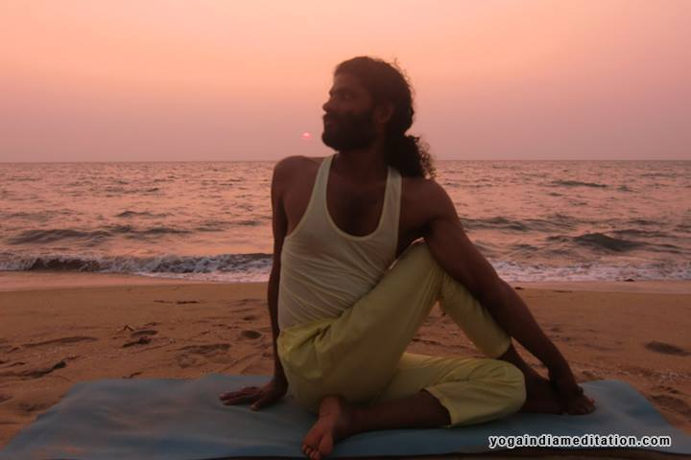

**Swami Yogeshananda (known as Yogeshji)**

**Philosophy & Sanskrit Scholar**

Born and educated in Tamil Nadu, Swamiji is a disciple of famous Swami Dayanada Saraswati. He studied Sanskrit language and traditional scriptures from 1992 to 1998 in Arsha Vidya Gurukulams in Rishikesh and Tamil Nadu. He was initiated into complete monkhood (Sannyasa) by Swami Dayananda Saraswati in 1998. For the past 14 years, he has been teaching Sanskrit, Vedantic Scriptures and Bhagavad Gita in different places in Japan, India and Sri Lanka.

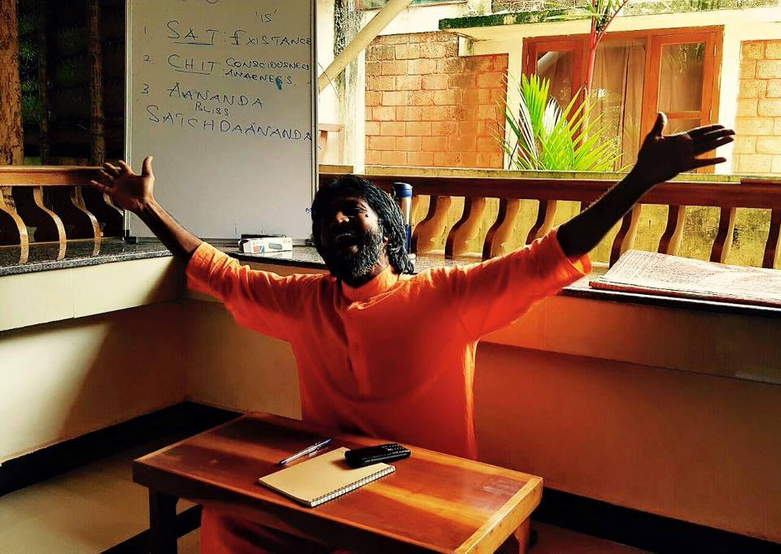

Read more about their work through their website:

<http://www.yogaindiameditation.com/index.html>

**Meet Your Hosts**

**Tracey Burrows**

**Founder of Om Yoga Bahrain**

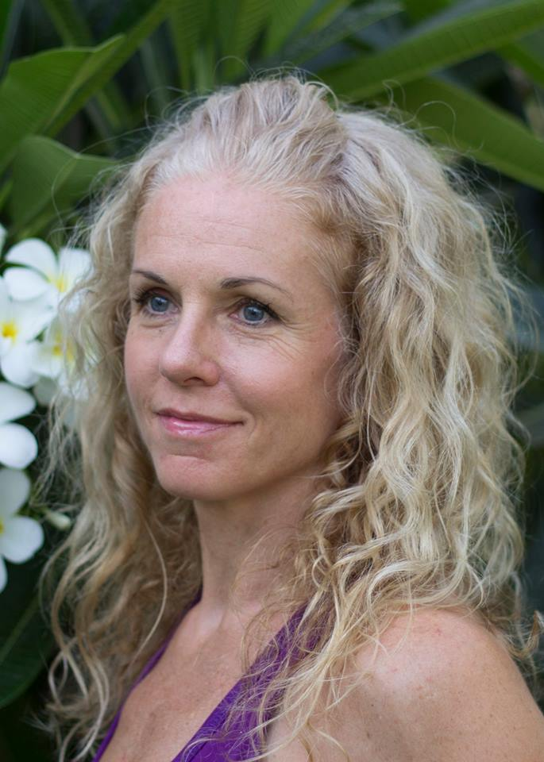“Originally from England I have lived with my husband in the Middle East for 16 years. We now live on the tiny island of Bahrain which has been our happy home for the past 7 years. I have a background in massage and holistic healing therapies and feel honoured to be offering Yoga, Meditation and Ayurveda coaching as my full time job/passion/life purpose.

I first met Bhoomaji, Swamiji and the team 3 years ago when I studied with them at Panmana Ashram in Kerala. I have been making the short trip back to India to further my studies as often as I can since then. My last trip was in January 2017 when I visited the Moozikkhulam Sala in Cochin.”

**Reem Al Mealla**

**Founder of Inspiring Change**

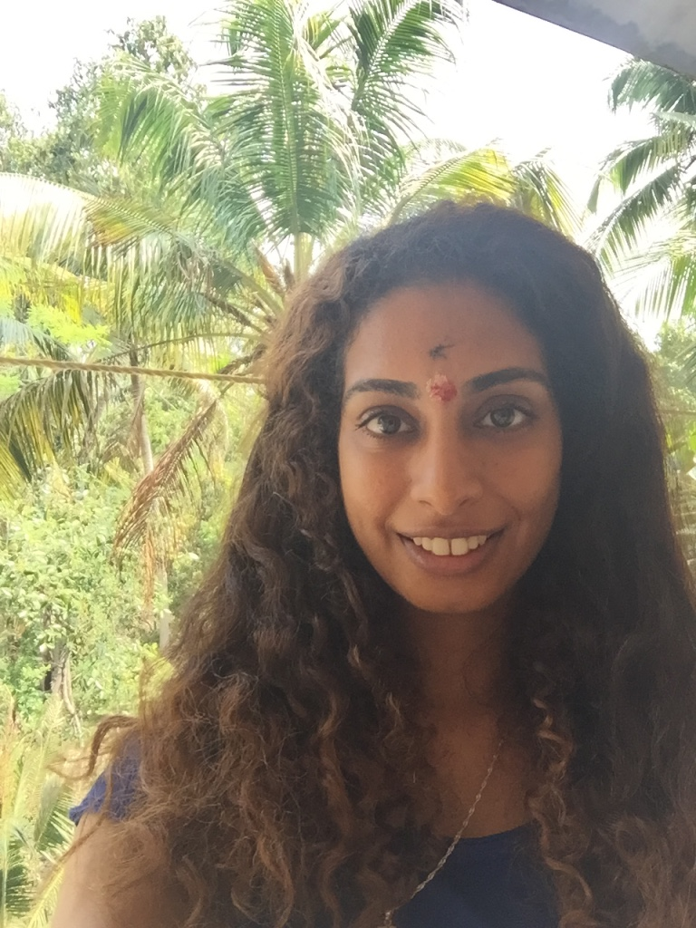

“I am a nature lover by default, a marine biologist by profession and a spiritual being by nature. My personal journey on the mat started in 2010 and since then my passion for helping people through yoga, pranayama, meditation and reiki has become endless. I am a certified yoga teacher (RYT 200) and reiki healer who’s teaching style is based upon encouraging people to connect with their body, mind and soul. I have had the privilege to teach both in Bahrain and the UK and have deep love for sharing the humble knowledge that I’ve acquired through my personal journey as I travel the world, discovering myself.”

**Retreat Location:**

Moozhikkulam sala is the unity of a group of people who are concerned about mother earth, human beings, nature and all other animate and inanimate beings. Our location for this immersion is the safe and welcoming Jaiva campus. The campus is a small eco village situated in beautiful natural surroundings, around 45 minutes drive from the popular visitors attractions of Fort Cochin and the famous backwaters of Allepey.

Cochin is a safe and popular area for travelling, rich in nature and diverse in culture. A perfect place to explore should you want to extend your stay once the course finishes.  Looking directly over the Chalakkudy River, your eco friendly, traditional Keralan style cottage offers very basic single accommodation with bed, your own western style bathroom and ceiling fan.  Please note that accommodation is basic offering a humble lifestyle – do not expect luxury! Meals are served in the traditional Keralan style dining hall. Delicious South Indian meals will be freshly cooked, seasonal and vegetarian.

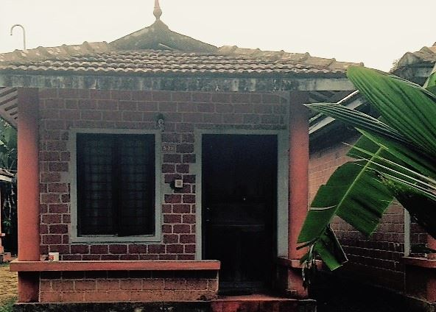

**Weather in Cochin:**

The average temperature in August is 24-29 degrees Celsius. Even though the rainy season will be coming to an end at the time, make sure you pack your umbrella just in case.

**Course fees for Bahrain:** BHD 300

**Course fees for UK / University of Essex Students:** £550 [If you are a registered member of the Yoga & Meditation Society at the University of Essex, you are eligible for a £50 discount which will be refunded to you through the society].

**What is included in the fees:**

* 10 nights accommodation in private room with ensuite bathroom
* Airport Pick Up from Cochin airport to Jaiva campus and back to Cochin airport
* Food on campus,
* Yoga and Meditation Sessions Everyday
* Yogic & Vedic Philosophy Classes Everyday
* Cultural Demonstration Event
* 1 day Excursion to Fort Cochin and the backwaters of Alleppey

**The fees does not include:**

* International Flights to India
* Visa Fees
* Travel Insurance
* Meals during Excursion Day

**To Register:**

DEPOSIT of BD100 is due by 3 May 2017

BALANCE of BD200 is due by 3 July 2016

Please email Tracey for details: [burrowstracey@yahoo.com](mailto:burrowstracey@yahoo.com)

**UK / University of Essex Students**

DEPOSIT of £250 is due by the 30th of April 2017

BALANCE of £300 is due by the 30th of June 2017

Please email Reem for details: rksalm@essex.ac.uk

***Please note that the deposit is non-refundable***

***This retreat is open to anyone from around the world! It is definitely not restricted to one group – all are welcome!***

**Daily Schedule:**

You will be sent the exact daily schedule closer to the time but here's a teaser:

5:30 am: Wake Up

5:45 am: Neti - Nasal cleansing

6:00 am: Meditation

6:30 am: Ginger tea

7:00 – 9:15 am: Asana & Pranayama Session

9:30 – 10:30 am: Breakfast

10:30 am – 12:30 pm: Yoga Philosophy

12:30 – 1:00 pm: Fruits

1:00 – 4:00 pm: Free time

4:00 – 6:00 pm: Yoga & Pranayama Session

6:30 – 7:30 pm: Dinner

7:30 – 8:30 pm: Evening programme (Mantra Chanting, Cultural Event, Discussion, or Free time depending on the day)

9:00 pm: Lights go out

There will be one day off for an excursion to visit historic and charming Fort Cochin, take a boat ride on the tranquil Alleppey backwaters and relax on Cherai beach.

Please note that for the welcome ceremony (Puja) which takes place in the ashram temple you will need white clothing. It can be anything that follows the above guidelines. You won't need them for yoga but you'll be sitting for about 90 minutes during the ceremony so they should be loose and comfortable.

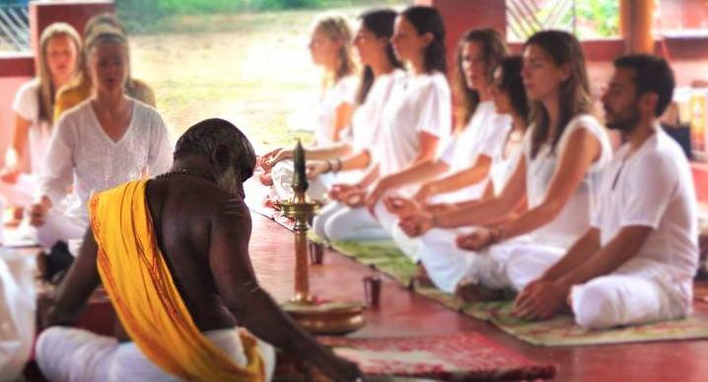

**Food:** South Indian Vegetarian. Includes diary, gluten and nuts. If you have any allergies please let us know in advance for us to be able to cater to your needs!

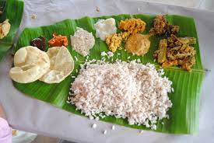

**Visa requirements:**

Since we have a very international group, please make sure you check the visa requirements based on your nationality and check the Indian Embassy’s website based on the country you are currently in!

**For those travelling from Bahrain:**

The visa process is quite simple, you just fill the form online and submit it at the IVS Office. You will need the address of where you will be staying. The visa processing is estimated to take two weeks during the summer but sometimes can take 5 days during the non-busy season.

**Submission Timings:**

Saturday to Thursdays 08.00 AM to 1.00 PM

Saturday to Thursdays 04.00 PM to 8.00 PM

Lunch Time:-01:00 P.M. to 04:00 P.M

**Last Token Issued at 07:30 PM**

**Collection Timings:**

Saturday to Thursdays 04.00PM to 06.00PM

**Address:**

IVS Global Services Pvt. Ltd.

Ground Floor, Building No. 26

Abi Obadiah Avenue

Road 302, Block 304 near Air India Office

Yusuf bin Ahmed Kanoo Building

Bab-Al-Bahrain, Manama, Bahrain

**For information call**: +973 13633433

**Website:** <http://www.ivsbahrain.com>

**Email:** [info.bahrain@ivsglobal.in](mailto:info.bahrain@ivsglobal.in)

**For those travelling from London:**

UK nationals and most EU countries seem to be eligible and hence may apply online minimum 4 days in advance of the date of arrival with a window of 30 days. Please make sure that this does apply to you.

You can check if you are eligible for an e-visa through the following link: <https://indianvisaonline.gov.in/visa/tvoa.html>

**Address:**

Public Response Unit

High Commission of India, London

**Nearest Tube Stations:** Holborn, Covent Garden, Temple and Charing Cross

**For information call**: +44 (0) 2086295950 (Monday – Friday: 0930 - 1700)

**Website:** <https://www.hcilondon.in/index.php>

**Email :** [info.london@hcilondon.in](mailto:info.london@hcilondon.in)

**Vaccination requirements:** Kindly note that Kerala is a malaria-free zone however, it is advisable to check other vaccination requirements.

**Packing list**

Here are a few ideas based on our previous retreat:

* White clothing for the opening and closing ceremonies.
* A shawl or scarf to cover the shoulders [please remember you will be staying in a conservative area surrounded by locals and leading an ashram lifestyle so modesty is key here! No tight fitting or transparent clothes and no short shorts please! This is crucial especially when visiting temples.]
* A cardigan for early morning meditation as it can get chilly!
* Bath towels
* All toiletries- include a nail brush and something to scrub your feet as you will be walking around bare foot in some areas.
* Mosquito repellant and after care gel for bites or stings
* Pif Paf plug in for mosquitos and/or mosquito net
* Socket adaptors- Two pin from wall
* Clothes washing powder
* Any medication you think you might need
* Torch
* Water bottle
* Yoga mat
* Small bag to carry money, room keys, books around
* Flip flops for the shower
* Closed/waterproof shoes in case of rain
* Umbrella
* Pens and pencils

**Last Year’s 2016 Retreat Testimonials:**

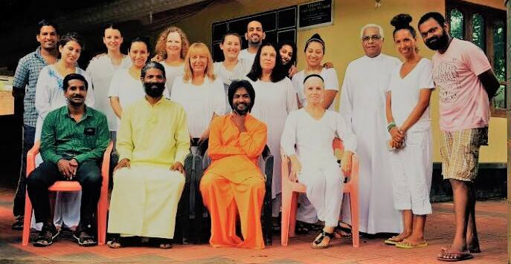

"What can I say! I found it amazing! As an experience, I believe is something everyone should do."

"I thought I would be out of my depth being a yoga novice, but discovered that yoga is a personal journey and not a competition."

"We were such a diverse group but through the philosophy discussions we discovered we really are one. Kerala healed my body and soul."

“What I really loved about the yoga immersion last year was the philosophy lessons by Swamiji! It had many questions answered, and many unanswered, but set me on a path to find these answers.”

" The food was top-notch and was not only cooked with love, but also served with much love and generosity."

"The Asana classes were intense, and very challenging...but also respected every individual person's physical abilities and limits."

**Gift yourself 10 days to connect with yourself through joining us in India this year. We look forward to welcoming you!**

**Om,**

**Tracey & Reem**

